Ashcon Abae

Signals and Systems

23 November 2019

Project 2

1. **Problem 4.33 in Textbook (all parts)**  
   Given: $$\frac{d^{2}y(t)}{dt^{2}}+6\frac{dy(t)}{dt}+8y(t)=2x(t)$$ 
   1. Let’s take the Fourier Transform on both sides of this equation: $${\left(jω\right)}^{2}Y\left(jω\right)+6\left(jω\right)Y\left(jω\right)+8Y\left(jω\right)=2X(jω)$$ 
      We then get: $$\frac{Y(jω)}{X(jω)}=H\left(jω\right)=\frac{2}{-ω^{2}+6jω+8}$$ 
      We can use the Matlab reside function to perform a partial fraction expansion: $$H\left(jω\right)=\frac{1}{jω+2}-\frac{1}{jω+4}$$ 
      Finally, we take Inverse Fourier Transform of above expression: $$h\left(t\right)=e^{-2t}u\left(t\right)-e^{-4t}u(t)$$ 
        
      >> n = [2]  
      >> d = [-1 6 8]  
      >> rpk = residue(n, d)  
        
      r =  
      1.0000  
      1.0000  
        
      p =  
      -2.0000  
      -4.0000  
        
      k =  
      []
   2. Given: $$x\left(t\right)=te^{-t}u\left(t\right)$$ 
      Taking the Fourier Transform of x(t): $$X\left(jω\right)=\frac{1}{{\left(jω+2\right)}^{2}}$$ From part a), we know $$H\left(jω\right)=\frac{Y\left(jω\right)}{X\left(jω\right)}=\frac{2}{\left(jω+2\right)\left(jω+4\right)} \\ →Y\left(jω\right)=\frac{2}{\left(jω+2\right)\left(jω+4\right)}X\left(jω\right) \\ →Y\left(jω\right)=\frac{2}{{\left(jω+2\right)}^{3}(jω+4)}$$ 
      We can use the Matlab residue function to perform a partial fraction expansion: $$Y\left(jω\right)=\frac{1/4}{jω+2}-\frac{1/2}{{\left(jω+2\right)}^{2}}+\frac{1}{{\left(jω+2\right)}^{3}}-\frac{1/4}{jω+4}$$ 
      Finally, we take the Inverse Fourier Transform of the above expression: $$y\left(t\right)=\frac{1}{4}e^{-2t}u\left(t\right)-\frac{t}{2}e^{-2t}u\left(t\right)+\frac{t^{2}}{2}e^{-2t}u\left(t\right)-\frac{1}{4}e^{-4t}u(t)$$ 
      >> n = [2]  
      >> d = [1 1 1 1 18]  
      >> rpk = residue(n, d)  
        
      r =  
      0.2500  
      -0.5000  
      1.0000  
      0.2500  
        
      p =  
      -2.0000  
      -4.0000  
      -8.0000  
      -4.0000  
        
      k =  
      []
   3. Let’s take the Fourier Transform of the given differential equation: $$Y\left(jω\right)\left[-ω^{2}+\sqrt{2}jω+1\right]=X\left(jω\right)\left[-2ω^{2}-2\right] \\ →H\left(jω\right)=\frac{Y\left(jω\right)}{X\left(jω\right)}=\frac{2(-ω^{2}-1)}{-ω^{2}+\sqrt{2}jω+1}$$ 
      We can use the Matlab residue function to perform a partial fraction expansion: $$H\left(jω\right)=2+\frac{-\sqrt{2}+\sqrt{2}j}{jω+\frac{1-j}{\sqrt{2}}}+\frac{-\sqrt{2}-\sqrt{2}j}{jω+\frac{1+j}{\sqrt{2}}}$$ 
      Finally, we take the Inverse Fourier Transform of the above expression: $$h\left(t\right)=2δ\left(t\right)-\sqrt{2}\left(1-j\right)e^{-\frac{\left(1-j\right)}{\sqrt{2}}t}u\left(t\right)-\sqrt{2}(1+j)e^{-\frac{\left(1+j\right)}{\sqrt{2}}t}u(t)$$
2. **Problem 4.34 in Textbook (part b)**
3. Given the frequency response of LTI system S: $$H\left(jω\right)=\frac{jω+4}{6-ω^{2}+5jω}$$ 
   We can split the denominator above into 2 factors: $$H\left(jω\right)=\frac{jω+4}{\left(jω+2\right)\left(jω+3\right)}$$ 
   We can use the Matlab residue to perform a partial fraction expansion: $$H\left(jω\right)=\frac{2}{jω+2}-\frac{1}{jω+3}$$ 
   Finally, we take the Inverse Fourier Transform of the above expression: $$h\left(t\right)=2e^{-2t}u\left(t\right)-e^{-3t}u(t)$$
4. **Problem 9.22 in Textbook (part e)**
5. >> n=[1 1]; %n=s+1  
   >> d=[1 5 6]; %d=s^2(s+2)=s^2+5s+6  
   >> [r p k]=residue(n d);  
     
   r =  
   2  
   -1  
     
   p =  
   -3  
   -2  
     
   k =  
   []  
     
   This shows us that our partial fraction expansion is: $$F\left(s\right)=\frac{2}{s+3}-\frac{1}{s+2}$$ 
   Next, we take the inverse Laplace transform:  
     
   >>syms s t  
   >> F = 2/(s+3) – 1/(s+2);  
   >> ilaplace(F, t)  
     
   answer = $2e^{-3t}u(t)-e^{-2t}u(t)$
6. **Problem 9.7 in Textbook**>> n=[1 -1];  
   >> d=[1 6 12 11 6];  
   >> sys1=tf(n,d)  
   >> pzmap(sys1)  
     
   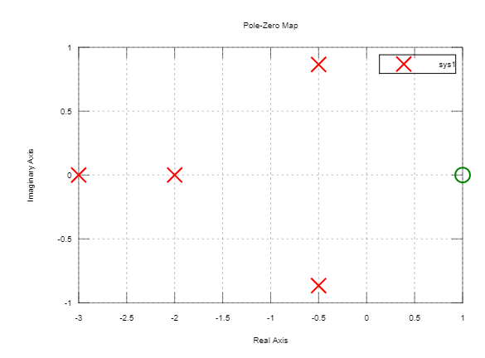  
   1. >> n1 = [1 1]  
      >> d1 = [1 2]  
      >> G1 = tf(n1, d1)  
        
      >> n2 = [1]  
      >> d2 = [500 0 0]  
      >> G2 = tf(n2, d2)  
        
      >> G3 = G1*G2 %forward path transfer function  
        
      >> [n d] = series(n1, d1, n2, d2)  
      >> printsys(n, d)  
      >> sys = tf(n, d)
   2. >> impulse(G3) %plots impulse response of G(s) found in part a  
        
      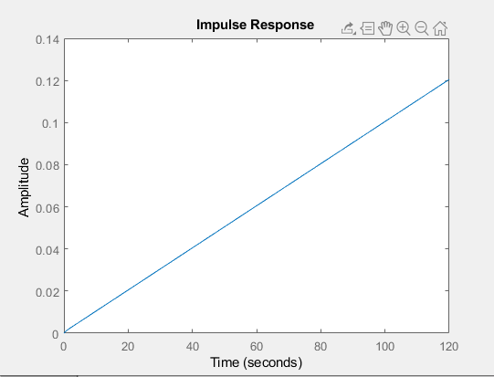
   3. >> step(sys)  
      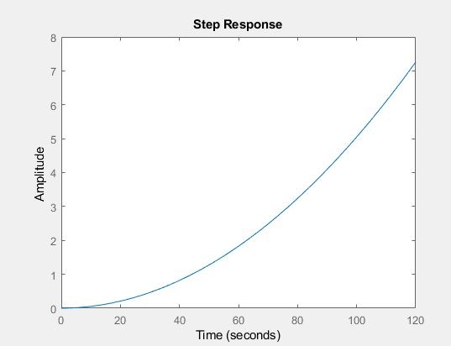
   4. >> T=0:0.002:5;  
      >> U=cos(15.7*T) .* exp(-T);  
      >> lsim(sys, U, T)  
        
      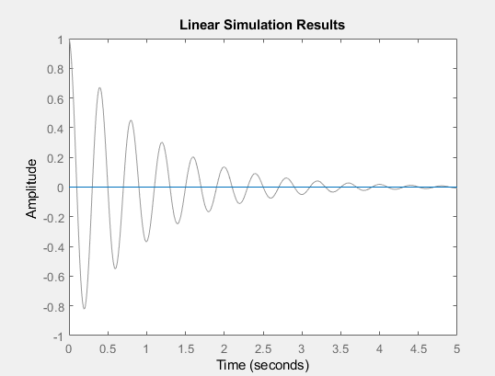
   5. >> [p z] = pzmap(G3) %since all poles lie on left side of s-plane, system is stable  
        
      p =  
      0  
      0  
      -2  
        
      z =  
      -1
   6. pzmap(G3)  
      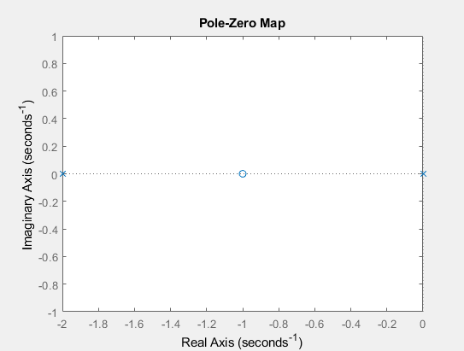
   7. >> n1 = [1 1]  
      >> d1 = [1 2]  
      >> G1 = tf(n1, d1)  
        
      >> n2 = [1]  
      >> d2 = [500 0 0]  
      >> G2 = tf(n2, d2)  
        
      >> G3 = G1*G2 %forward path transfer function  
      >> G = feedback(G3, 1) % closed loop transfer function with % gain of feedback path = unity
   8. >> [n d] = series(n1, d1, n2, d2)  
      >> printsys(n, d)  
      >> sys = tf(n, d)
   9. >> impulse(G) %plots impulse response of G(s) found in part a  
      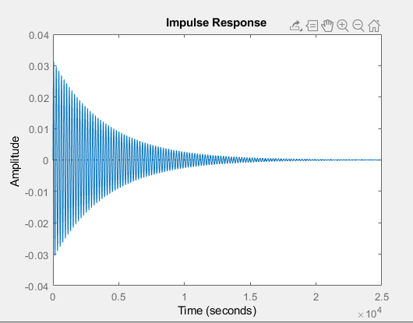  
        
      Adding feedback to this system reduces the overall gain of the system with the degree of reduction being related to the systems open-loop gain.
   10. >> [p z] = pzmap(G) %since all poles lie on left side of s-plane, system is stable  
         
       p =  
       -1.9995 + 0.0000i  
       -0.0002 + 0.0316i  
       -0.0002 - 0.0316i  
         
       z =  
       -1
   11. >> pzmap(G)  
       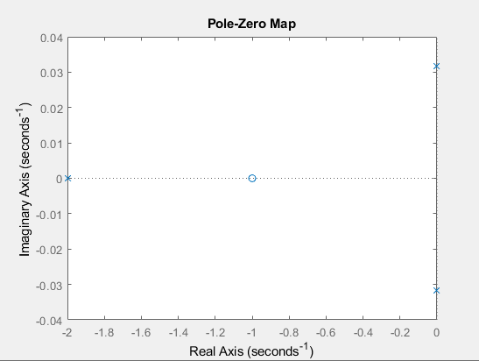
   12. >> T=0:10:20000;  
       >> U=cos(0.006*T) .* exp(-T/10000);  
         
       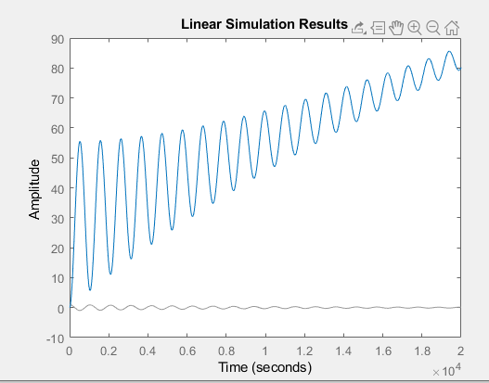
7. 1. >> n1 = [1]  
      >> d1 = [500 0 0]  
      >> G1 = tf(n1, d1)  
        
      >> n2 = [1 1]  
      >> d2 = [1 2]  
      >> H1 = tf(n2, d2)  
        
      >> G = feedback(G1, H1)
   2. >> [n d] = series(n1, d1, n2, d2)  
      >> printsys(n, d)  
      >> sys=tf(n, d)
   3. >> impulse(G) %plots impulse response of G(s) found in part a  
        
      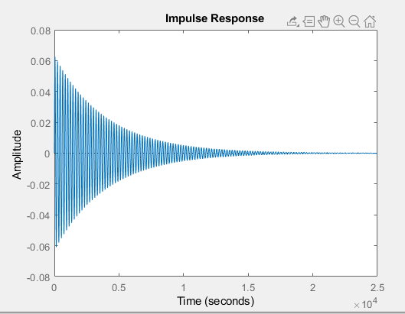
   4. >> [p z] = pzmap(G) %since all poles lie on left side of s-plane, system is stable  
        
      p =  
      -1.9995 + 0.0000i  
      -0.0002 + 0.0316i  
      -0.0002 - 0.0316i  
        
      z =  
      -2
   5. >>pzmap(G)  
        
      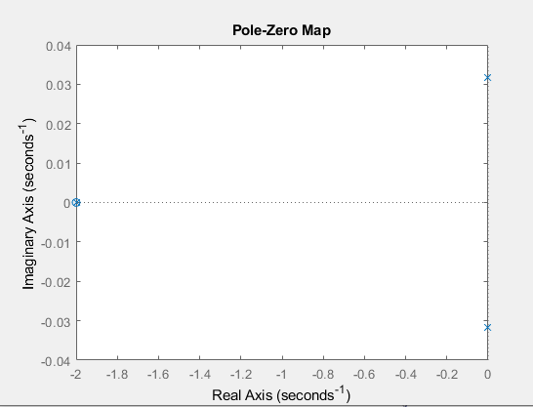
   6. Given: $$y\left(n\right)=0.6y\left(n-1\right)+x\left(n\right)$$ 
      Taking Z transform in above difference equation: $$Y\left(z\right)=0.6z^{-1}Y\left(z\right)+X\left(z\right) \\ →H\left(z\right)=\frac{Y\left(z\right)}{X(z)}=\frac{1}{1-0.6z^{-1}} \\ >> n = [1] \\ >> d = [1 -0.6]$$ $>>$
      zplane(n, d)  
        
      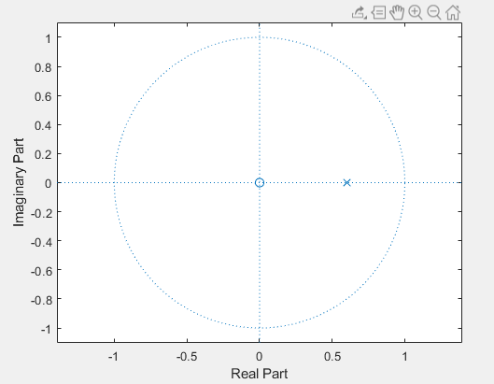  
        
      Because the pole lies inside the unit circle, the system is stable.
   7. >> freqz(n, d, 1024)  
        
      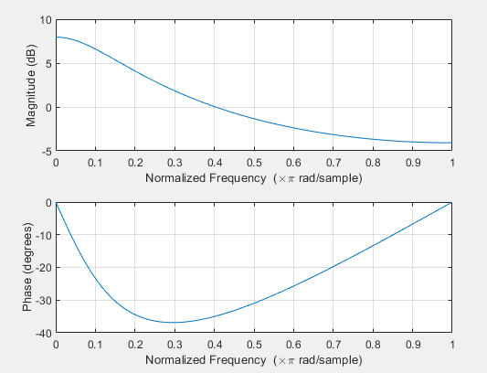
   8. >> impz(n, d)  
        
      